
International School

Capstone Project 1
CMU-SE 450/CMU-IS 450/CMU-CS450

Architecture Design
Version 1.3
Date: 14 October 2026

SmartRegression AI: An LLM- and RAG-Based Change Impact Analysis and Regression Test Selection System

Submitted by

Huy, Nguyen Tan - 29211154944
An, Do Ha - 29211258599
Huy, Pham Phan Hoang - 29211156999
Khanh, Tran Hung - 29219065410
Viet, Dang Dai - 29211155820

PROJECT INFORMATION

Project acronym | SmartRegression AI
Project Title | SmartRegression AI: An LLM- and RAG-Based Change Impact Analysis and Regression Test Selection System
Start Date | 23 Aug. 2026 | End Date | 13 Dec. 2026
Lead Institution | International School, Duy Tan University
Project Mentor | JAN SAMUELSSON
Scrum master / Project Leader & contact details | Huy, Nguyen Tan | Student ID: 29211154944  Email: nguyentanhuy46205@gmail.com | Tel: 0932401249
Partner Organization | Duy Tan University
Project Web URL | Not yet provided (no public project URL recorded)
Team members | Name | Email | Tel
29211154944 | Huy, Nguyen Tan | nguyentanhuy46205@gmail.com | 0932401249
29211258599 | An, Do Ha | Anha0664@gmail.com | 0815737920
29211156999 | Huy, Pham Phan Hoang | phamphanhoanghuy2005@gmail.com | 0932509973
29219065410 | Khanh, Tran Hung | Thungkhanh19@gmail.com | 0783494325
29211155820 | Viet, Dang Dai | vdang9721@gmail.com | 0384165721

REVISION HISTORY

Version | Date | Comments | Author | Approval
1.0 | 14 Oct. 2026 | Initial project architecture draft. | C1SE.26
1.1 | 14 Oct. 2026 | Modify Document. | C1SE.26
1.2 | 14 Oct. 2026 | Refined core architecture and views. | C1SE.26
1.3 | 14 Oct. 2026 | Expanded architecture reasoning, scenarios, contracts and diagrams. | C1SE.26

Contents
1. Introduction 5
1.1 Purpose 5
2. Project Overview 5
2.1 Business needs 5
2.2 Proposed solution 6
2.3 Business drivers 6
2.4 Project goal 6
3. Architectural drivers 7
3.1 Functional requirements 7
3.2 Business constraints 9
3.3 Technical constraints 9
3.4 Quality Attribute 11
3.5 Context Diagram 13
4. C&C view 15
4.1 Primary execution scenario 16
4.2 Connector and data contracts 18
4.3 Deterministic selection and fallback 18
4.4 Failure containment and research isolation 20
5. Module view 20
5.1 Module responsibilities 21
5.2 Module dependency and integrity rules 22
5.3 Persistent data organization 23
6. Allocation view 24
6.1 Node allocation and operational responsibilities 25
6.2 Deployment choices and non-goals 25
6.3 Architecture verification plan 26
6.4 Design decisions requiring confirmation 26

1. Introduction

1.1 Purpose
This Architecture Design document specifies the structural organization and principal engineering decisions for SmartRegression AI, a web-based system that analyzes code changes and recommends which existing regression tests to execute. It establishes how the application handles external integrations, stores evidence, makes test-selection decisions and isolates execution of repository code.
The design is expressed through complementary architectural views. The context view defines the system boundary and its external stakeholders; the Component-and-Connector (C&C) view describes runtime interactions and data movement; the module view describes responsibility and dependency boundaries; and the allocation view maps software components to the proposed execution environment.
The architecture is intended to guide implementation, integration testing and technical review. It distinguishes committed product behavior from proposed implementation mechanisms: the MVP behavior is fixed by the stated requirements, whereas individual framework, model and deployment choices remain subject to team validation.

2. Project Overview

2.1 Business needs
Source changes may affect callers and dependent components beyond the directly edited lines. Developers need a consistent way to locate review starting points and inspect dependency and source evidence rather than relying entirely on manual inspection.
QA and DevOps teams need to avoid unnecessary full-suite execution while keeping regression risk visible. An unexplained short list of tests is insufficient: every dispatched identifier must refer to a discovered test at the analyzed target version, and uncertainty must lead to a conservative, recorded outcome.
For academic evaluation, the same change and test-selection artifacts must be reproducible and comparable with independent full-suite, dependency-based and LLM-only baselines. End-to-end costs, missed faults and failed runs must remain measurable rather than being omitted from the result.

2.2 Proposed solution
SmartRegression AI accepts an authorized GitHub repository and a pair of commits or pull-request revision. It freezes the resolved source versions, identifies modified code using Git differences and supported parsing, traverses a dependency graph to find possible consumers, and discovers the set of executable tests in the target revision.
A commit-scoped retrieval index supplies relevant source code, existing tests and documentation to the LLM. Model output is treated only as a proposal. A deterministic validation and selection policy checks test inventory membership, evidence references and analysis completeness before producing an immutable selection manifest. The user may instead request the full suite. A constrained runner performs test discovery and execution, while reports and research experiments reuse the saved results.

2.3 Business drivers
Driver | Architectural response
Explainable impact review | Preserve changed/affected distinctions, source locations, dependency paths, information gaps and versioned evidence.
Safe reduction of regression effort | Use an inventory-validated hybrid selection and conservative fallback; never treat an analysis error as an empty test set.
Short user-facing response | Keep web requests short and process analysis/test execution asynchronously with bounded workers.
Responsible use of external AI | Separate deterministic policy from LLM proposals; redact secrets; pin context to the repository and commit.
Reproducible evaluation | Freeze requests/configurations/manifests, retain artifacts, isolate labels, report complete timings and baseline outcomes.

2.4 Project goal
The goal of the Capstone 1 prototype is to implement and empirically assess evidence-backed change-impact analysis and existing regression-test selection for one supported programming language and one testing framework. The product supports five connected capabilities:
• Repository setup and lifecycle: connect an authorized GitHub repository; validate test settings; freeze base/target commits; submit and monitor a run (FR-01–04).
• Impact analysis and review: identify changed and potentially affected components, verify evidence, and present deterministic review starting points (FR-05–08).
• Existing-test selection: discover the target inventory; construct complete selected/not-selected groups with explanations and fallback warnings (FR-09–12).
• Controlled execution: run a validated subset or full suite in an isolated environment; return per-test outcomes and failure classes (FR-13–14).
• Reporting and research: reopen run history, export HTML/JSON, integrate one CI/CD platform and compare predefined baseline methods (FR-15–18).
The MVP excludes public self-registration, test generation, automatic code repair, multi-language analysis, arbitrary experiment builders, full cross-repository reasoning and requirement-level traceability. These boundaries keep the architecture feasible for a five-member team.

3. Architectural drivers

3.1 Functional requirements
The following externally observable requirements drive component boundaries. Internal Product Backlog items PB19–PB22 add indexing, retrieval, LLM output validation and selection-policy capabilities required to satisfy them.
ID | Function | Architecturally relevant behavior
FR-01 | Connect repository | Authorize access; track repository identity, connection status and failures.
FR-02 | Configure testing | Validate framework, test paths, approved commands and resource/time limits.
FR-03 | Select change | Resolve and freeze base/target SHAs; PR changes create a new run.
FR-04 | Monitor analysis | Idempotent request, run ID, stages, status and terminal reason.
FR-05 | Review code changes | Display supported changed files/components, diffs and versioned source locations.
FR-06 | Review potential impact | Show changed/direct/indirect components and supported dependency paths.
FR-07 | Inspect explanations | Verify commit/source/dependency evidence; disclose gaps and invalid references.
FR-08 | Review starting points | Stable ranking: changed executable → direct → indirect; location tie-break.
FR-09 | View existing tests | Discover stable target-version test IDs; distinguish empty vs failed discovery.
FR-10 | Review selected test set | Freeze complete and disjoint selected/not-selected partitions with actual mode.
FR-11 | Inspect selection reasons | Show evidence or explicit policy rule for each decision or group.
FR-12 | Review fallback | Explain expanded/full-suite/stop outcome when analyses are incomplete.
FR-13 | Execute regression tests | Send validated manifest and frozen target SHA to isolated runner.
FR-14 | Inspect test results | Report pass/fail/runner-skip and distinguish runner/build/timeout errors.
FR-15 | Browse analysis history | Reopen original versions, settings, impact, selection and results.
FR-16 | View and export reports | Provide HTML and JSON with timings, evidence, fallback and available cost.
FR-17 | CI/CD integration | Support one platform; dedupe repeated events; nonpassing failure status.
FR-18 | Compare methods | Predefined evaluation against full suite, dependency and LLM baselines.

Internal design work supporting the requirements
Backlog | Internal responsibility | Owner module
PB19 | Index permitted source, tests and documentation per repository/commit. | Retrieval / Index Adapter
PB20 | Retrieve diff- and component-relevant chunks with citation metadata. | Retrieval / Context Builder
PB21 | Validate LLM schema, existing test IDs and evidence references. | Evidence Validator
PB22 | Freeze deterministic S = (D ∪ M ∪ L) ∩ T and fallback outcome. | Selection Policy
PB23 | Build frozen research datasets and independently reviewed labels. | Evaluation / Restricted Store
PB24 | Compare baseline methods and report valid denominators/overall costs. | Evaluation Service

3.2 Business constraints
Constraint | Design consequence
Schedule and team | Five members, four three-week development sprints (7 Sep–29 Nov 2026); final project delivery 13 Dec 2026. Prefer bounded modules over independent deployable microservices.
MVP technology scope | One analyzed language, one testing framework and one experimental CI/CD platform; capability adapters do not imply expanded supported scope.
Research validity | Controlled authorized repositories, independent reference outcomes, frozen configurations and separation of pilot versus held-out evaluations.
Resource ceiling | Limit worker concurrency, LLM calls/tokens, execution time and runner CPU/memory; show missing and exceeded budgets explicitly.
Safety and ethics | No automatic merge, code modification or test generation. Private repository content and credentials remain access-controlled.

3.3 Technical constraints
The preferred logical design is a modular monolith with an HTTP API, a separately schedulable asynchronous worker, adapter ports and an ephemeral isolated test runner. This does not imply that each module is independently deployable or requires a distributed message broker.
Area | Architectural selection or open decision
Implementation | Python 3.x is planned for Git/AST and backend integration; HTTP/UI framework is to be confirmed through the technical spike.
Repository analysis | GitHub initial integration; one language parser. Supported static imports and resolvable calls; dynamic behavior is an explicit information gap.
Persistence | Database Design v1.5 models PostgreSQL tables; Project Plan also permits SQLite for local MVP. PostgreSQL is the target pending implementation confirmation.
Retrieval / LLM | Commit-scoped vector retrieval using a replaceable index adapter. Provider/model, embedding index and token budget must be pinned for each run.
Execution | Ephemeral constrained runner; approved argument vectors, timeout, CPU/memory caps; no application/API secrets injected into test processes.
Integration | One CI/CD platform with authenticated calls, unique delivery keys and explicit result mapping.
Observability | Stage events and timings, run artifacts, provider usage/cost where available, and explicit error/fallback reasons.

Principal architecture decisions and rationale
Decision | Why selected for Capstone 1 | Trade-off / safeguard
Modular monolith | Simpler local integration, debugging and delivery by five members; domain boundaries remain explicit. | Less independent scaling; bound worker concurrency and keep provider ports replaceable.
Background workers | Analysis, retrieval and test execution can exceed web latency targets. | Persist stages, bounded retries and idempotent request keys; avoid untracked in-memory state.
Deterministic policy after LLM | Prevents unknown IDs or unsupported explanations from controlling execution. | May select extra tests; evaluate reduction and faults rather than assuming improvement.
Separate test sandbox | Untrusted repository tests cannot run with API/database credentials. | Requires a reproducible container/runner; fail closed if isolation unavailable.
Versioned run + evidence | Ensures reproducibility and cross-view agreement on repository SHAs. | More storage; reference protected immutable artifacts by digest/key.

3.4 Quality Attribute
Quality attributes are specified as testable scenarios rather than claimed project achievements. Targets follow the approved non-functional requirements; measurements are to be collected on a declared test environment.
Usability / NFR-01 (QA01)
Scenario element | Description
Stimulus | A software-literate trial user needs to select a change, start a run and inspect one impact evidence item.
Source(s) of the stimulus | Developer / QA user
Relevant environmental conditions | After a brief introduction; ordinary browser interaction.
Architectural elements | Web Dashboard; status and evidence queries
System response | Expose repository, both SHAs, status, next action and verifiable evidence.
Response measure(s) | At least 4 of 5 trial users complete these tasks in 10 minutes of active interaction, excluding processing wait.

Responsiveness / NFR-02–03 (QA02)
Scenario element | Description
Stimulus | Five users submit or query simultaneous analyses.
Source(s) of the stimulus | Trial users / CI integration
Relevant environmental conditions | Declared host/network; five users, bounded analysis workers.
Architectural elements | HTTP API; Run Orchestrator; Run Store
System response | Acknowledge/queue without blocking on LLM or tests; surface recorded status updates.
Response measure(s) | p95 acknowledgement/status ≤ 2 s; dashboard shows a recorded state within 5 s; accept ≥ 5 simultaneous requests without lost/mixed runs.

Security / NFR-07–09 (QA03)
Scenario element | Description
Stimulus | An unauthorized user, adversarial repo content or unsafe test attempts private access or secret leakage.
Source(s) of the stimulus | Unauthorized actor / untrusted repository or model output
Relevant environmental conditions | Private repository; external LLM; isolated test execution.
Architectural elements | Authorization; Context Builder; Runner Adapter
System response | Enforce per-repo access; redact secrets; treat LLM output as data; sandbox execution without application credentials.
Response measure(s) | Negative access, secret-leakage, prompt-injection and sandbox escape fixtures do not disclose secrets or bypass execution policy.

Reliability / NFR-04–05 (QA04)
Scenario element | Description
Stimulus | GitHub, parser, model or runner fails; a request is replayed.
Source(s) of the stimulus | External service / worker / CI delivery
Relevant environmental conditions | Partial run state at frozen SHAs.
Architectural elements | Run Store; Orchestrator; Selection Policy
System response | Record stage failures and bounded retries; conservative fallback when valid, otherwise explicit terminal error; dedupe requests.
Response measure(s) | No silently passing failed run, duplicate execution job, mutated source version or mixed-run result in simulated failures.

Traceability & maintainability / NFR-06,10 (QA05)
Scenario element | Description
Stimulus | Reviewer questions a test decision or a provider adapter is replaced.
Source(s) of the stimulus | Developer / maintainer / reviewer
Relevant environmental conditions | Historic run and test-double integration environment.
Architectural elements | Evidence Validator; ports; Report Service
System response | Resolve citations and reasons at frozen commits; isolate vendor adapters from policy.
Response measure(s) | Invalid citations marked unverified; adapter test doubles can replace GitHub/LLM/runner without rewriting selection algorithm.

Reproducibility & observability / NFR-11–12 (QA06)
Scenario element | Description
Stimulus | Evaluator repeats an experiment or analysis hits a time/token limit.
Source(s) of the stimulus | Evaluator / operator
Relevant environmental conditions | Versioned data, fixed runner environment and configured budgets.
Architectural elements | Evaluation Service; Run Events; Artifacts
System response | Retain versions, prompts, settings, timings, token usage, failure/fallback and N/A reason; enforce budgets.
Response measure(s) | An independent teammate can repeat a documented smoke run; missing values are not fabricated; limit violations are explicit.

3.5 Context Diagram
The system boundary includes the browser-facing application, orchestration, persistence, retrieval, selection policy and reports. Users and external services communicate through controlled interfaces; the database and retrieval index are internal, not independent external actors.
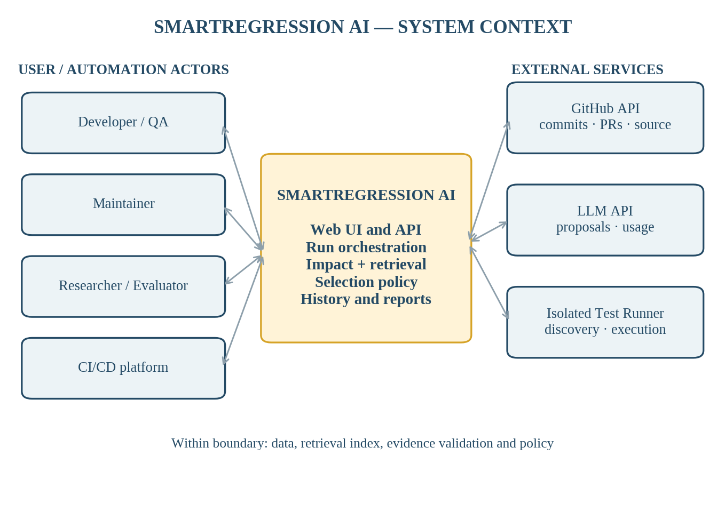
Figure 3.1. SmartRegression AI context and external interactions
External party | Exchange / request | Response / outcome
Developer / QA | Repository and versions, analysis/test requests. | Progress, impact/evidence, manifest and test results.
Maintainer | Repository connection, permission, test and CI configuration. | Status, access errors and resource events.
Evaluator | Frozen datasets, selected methods and evaluation requests. | Metrics, run validity, limitations and exports.
GitHub | Approved metadata/commit/PR/source requests. | Versioned code/diff metadata or access errors.
LLM API | Bounded prompt with approved retrieved context. | Proposed tests/impacts, usage or errors; never commands.
Isolated runner | Frozen target, approved test commands and manifest. | Inventory/results/logs/status or execution failures.
CI/CD | Signed/integrity-checked commit/PR delivery. | Idempotent status, outcome and artifact links.

4. C&C view
The Component-and-Connector view describes components cooperating during execution rather than source-code packages. The API and worker are separate runtime responsibilities, but may initially run on one controlled application host. Request/response calls cover short interactions; durable run state and worker claims cover long-running analysis.
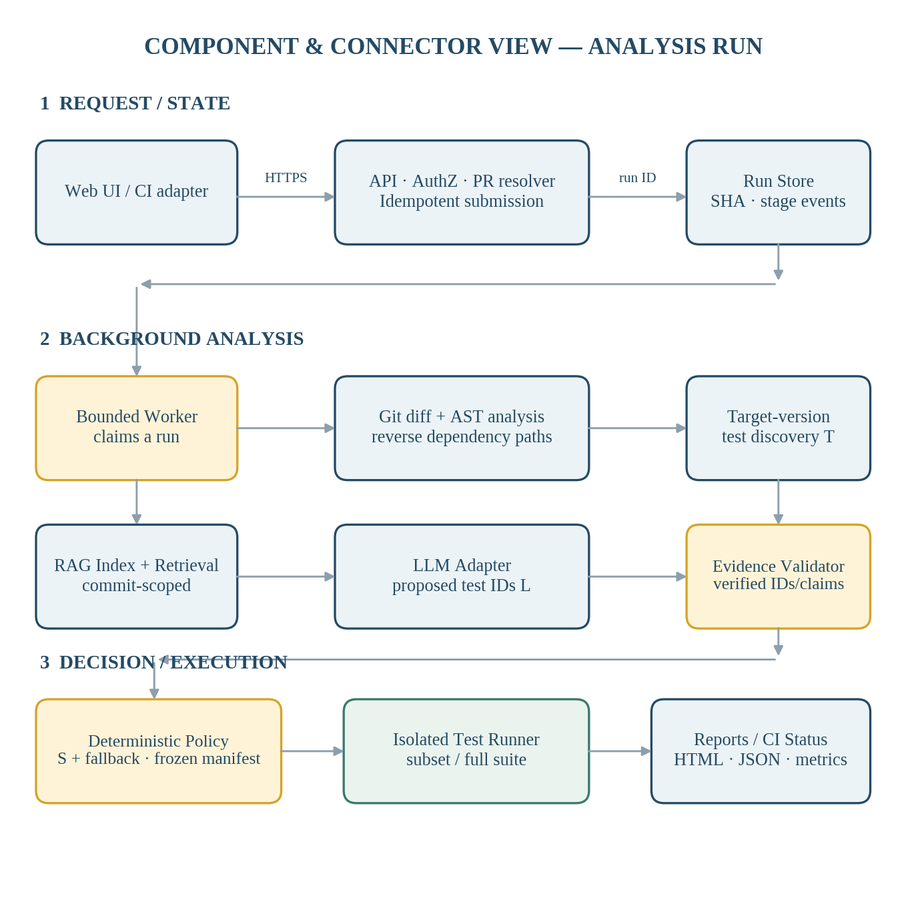
Figure 4.1. C&C view — request handling, analysis, decision and execution

4.1 Primary execution scenario
1. Authenticate the actor and authorize repository-level access. Resolve the GitHub commit pair or PR merge-base/head; create an idempotent analysis record containing base/target SHA, configuration ID and request key.
2. Return the run ID promptly. A bounded worker claims the queued run and writes append-only stage events, including measured duration and recoverable warnings.
3. Retrieve the frozen source revisions; compute file changes, supported AST components and import/call relationships. Traverse reverse dependency edges to determine changed, direct and indirect impact candidates.
4. Ask the isolated runner to discover existing tests in the target checkout; freeze inventory T with stable adapter-defined IDs and source locations. Treat empty-success and discovery-error as different outcomes.
5. Construct or reuse an index matching repository/commit, retrieve relevant chunks, redact restricted inputs and call the configured LLM under fixed token, time and retry budgets.
6. Validate structured model output, actual test identifiers and commit-linked evidence. The deterministic policy produces the decision partition and records fallback conditions.
7. Freeze a validated manifest before dispatch; execute the selected or requested full suite in an isolated environment; save per-test results, logs and classified errors.
8. Expose status/history and export HTML/JSON reports. Return a CI result that distinguishes ordinary success, successful full-suite fallback, neutral no-tests, and failure.

4.2 Connector and data contracts
Interface | Minimum exchanged data | Critical guarantee
UI / CI → API | repo, base/target or PR, configuration; identity/event key | authorization + idempotency; immediate run ID
API → worker | run_id; frozen SHA pair; config version | bounded claim; no concurrent duplicate job
Git adapter → impact | diff, base/target snapshots, components, parse outcomes | version-aligned source evidence and explicit gaps
Runner → inventory | target SHA, adapter/version, test IDs and status | only discovered IDs are eligible; empty ≠ failed
Retriever → LLM | approved chunks, SHA, locations, candidate tests | cost budgets; secret/label exclusion; untrusted model input
LLM → validator | structured proposals, IDs, citations, usage/error | invalid content cannot directly execute tests
Policy → runner | immutable validated manifest, target SHA, limits | approved command only; bounded isolation
Runner → reporting | job ID, results, logs, durations and error class | run-scoped artifact references and CI outcome

4.3 Deterministic selection and fallback
Let T be the frozen target-version inventory, D the existing tests associated with supported dependency relationships, M all new or modified target tests, and L the valid, evidence-backed additions proposed by the LLM. The normal-mode selection is S = (D ∪ M ∪ L) ∩ T. The LLM may add but cannot remove tests already in D or M. The complementary not-selected set is T − S; both groups must be disjoint, complete and recorded with reasons.
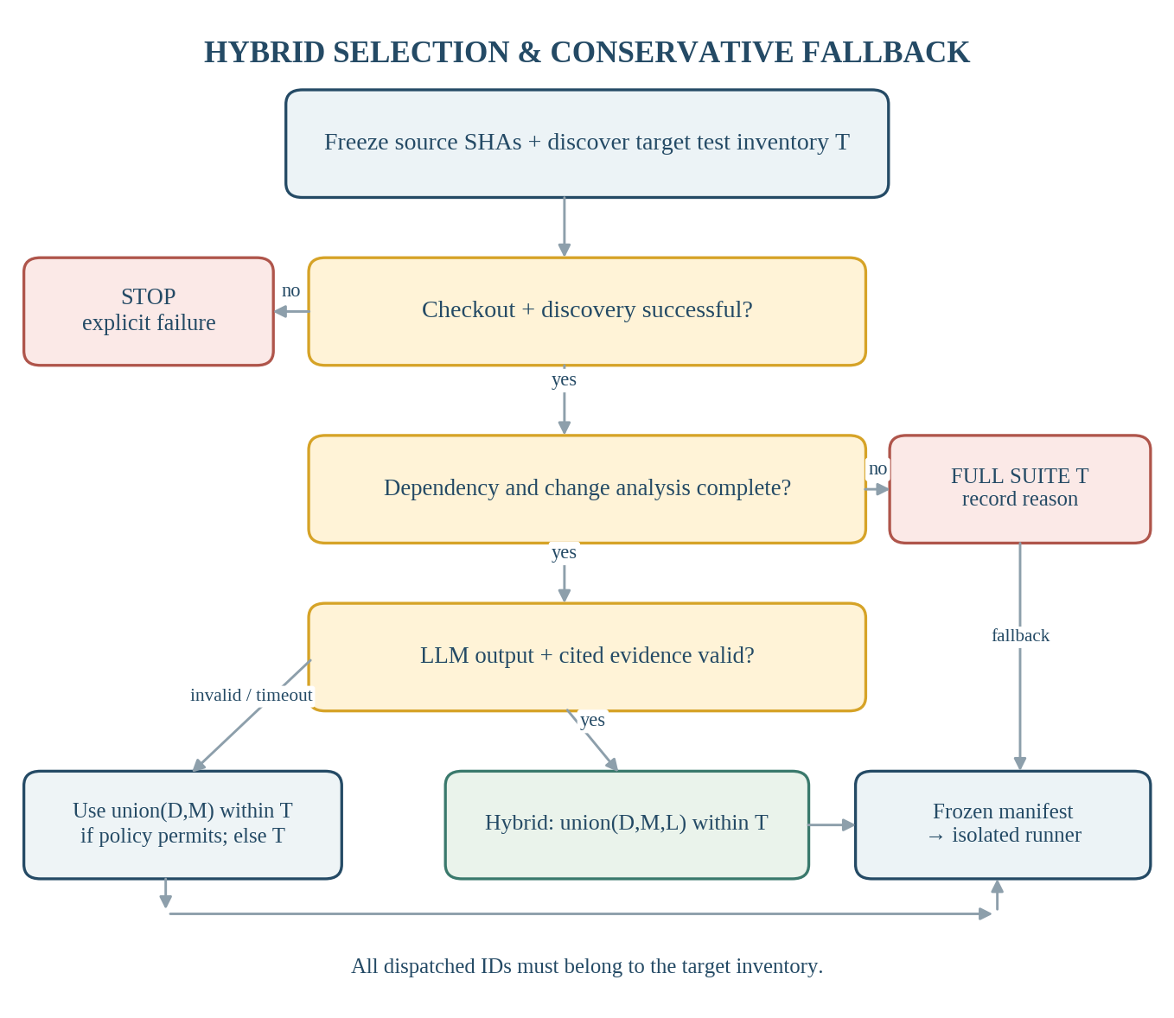
Figure 4.2. Selection validation and conservative fallback workflow
If the LLM times out or returns malformed output, the policy may use (D ∪ M) ∩ T only when dependency analysis remains valid and the configured rule permits this reduced mode; otherwise it selects T. Unsupported changed code, unresolved mapping, relevant build/test configuration changes or invalid essential evidence require full-suite fallback. Checkout/discovery failure, missing source revision or unavailable runner causes an explicit stop. A valid empty inventory is reported as no tests available, never as a passing regression check.
These are decision-safety rules, not a formal guarantee that all regression faults will be detected. The report retains policy version, trigger, final mode, complete inventory counts and evidence links.

4.4 Failure containment and research isolation
Failure or threat | Handling boundary
Duplicate CI delivery | Unique integration ID + delivery key; return existing run status instead of dispatching a new job.
Parser or dependency gap | Flag unsupported nodes and incomplete paths; choose policy fallback, not silent exclusion.
Unknown LLM test ID | Reject invalid additions, save validation outcome and apply recorded fallback.
Runner timeout / build error | Mark distinct unsuccessful execution status; do not translate into passed tests.
Missing usage/ground-truth data | Preserve NULL / N/A with reason; never synthesize values or score missing labels as zero.
Ground-truth leakage | Evaluation reference labels and full-suite outcomes remain inaccessible to selection until manifest frozen.

5. Module view
The module view separates source-code responsibilities and permissible dependencies. Business rules live in the domain core, use-case orchestration in the application layer, HTTP/UI concerns in presentation, and external services/storage behind adapter interfaces. This is a logical decomposition within the proposed modular monolith, not a mandate for separate repositories or independently deployed services.
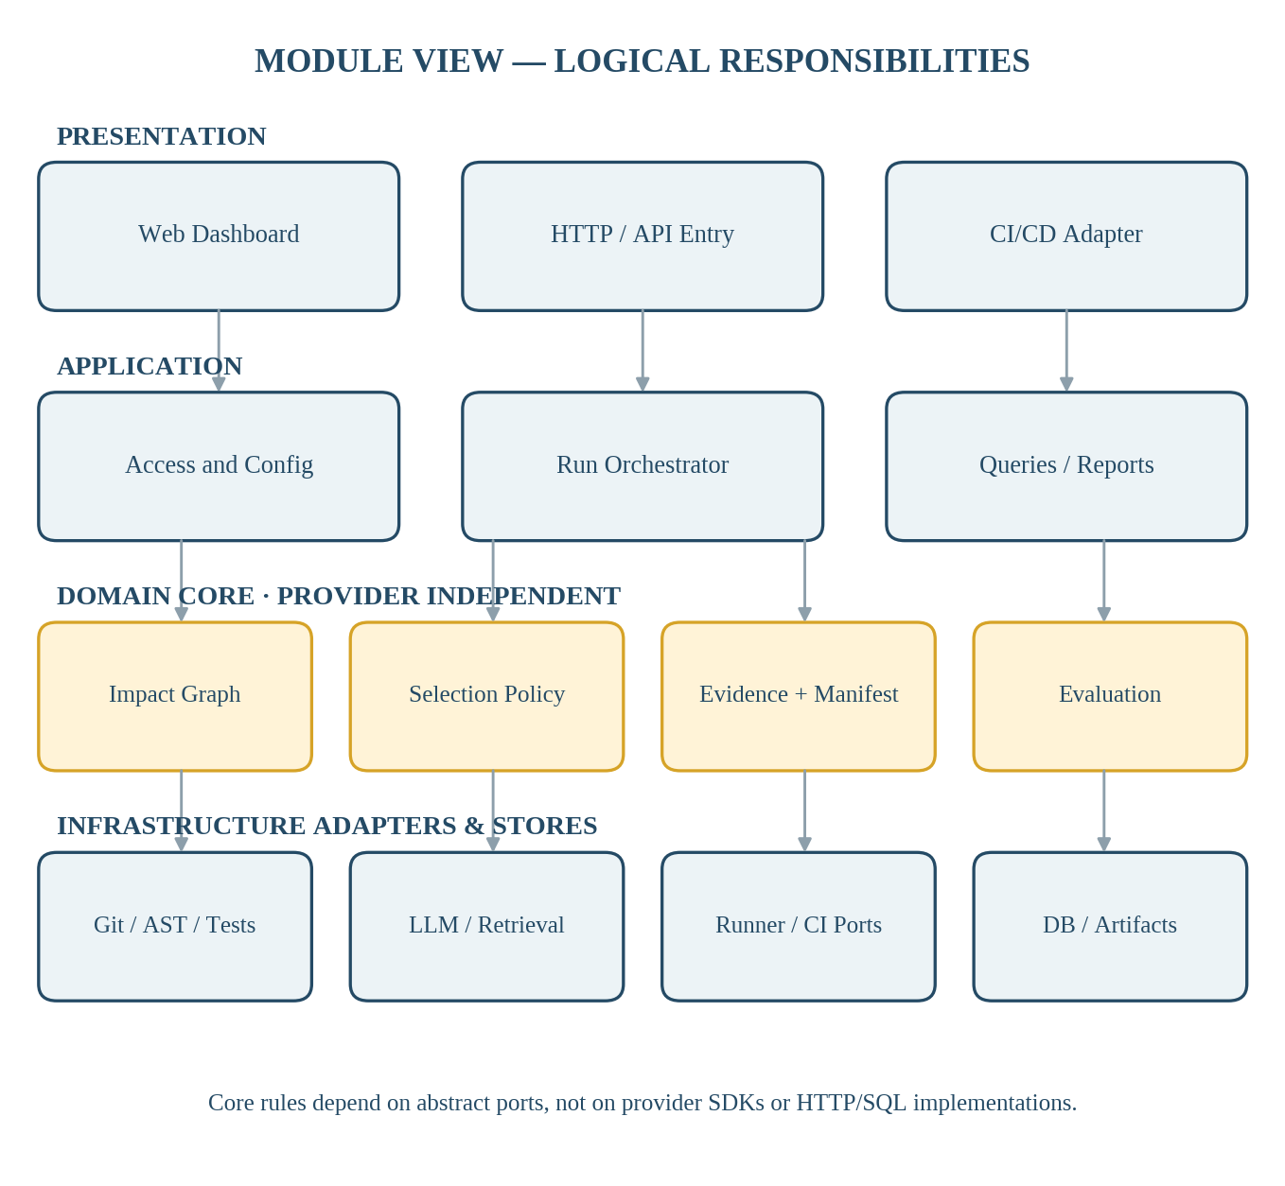
Figure 5.1. Module view — logical layers and dependency direction

5.1 Module responsibilities
Module / package responsibility | Owned decisions and outputs | Requirement mapping
Presentation / API | Authorized endpoints for setup, runs, impact/results, history and report export; CI event responses. | FR-01–04, FR-15–17
Run Orchestration | Freeze versioned inputs, schedule stages, enforce idempotency, retries, budgets and terminal statuses. | FR-03–04, FR-17
Repository & Change Analysis | Git snapshots/diffs; parse changed components; build supported import/call graph. | FR-05–06; PB05–06
Impact Evidence | Direct/indirect candidates, reverse paths, source citations, verified status and review ordering. | FR-07–08; PB07–08
Test Discovery | Adapter-defined inventory IDs, target revision, source locations, successful-empty distinction. | FR-09; PB09
Index & Context Builder | Commit-scoped chunk metadata, secret exclusion, diff-driven retrieval and context provenance. | PB19–20
LLM + Evidence Validator | Model request/response records, schema/ID/citation validation, trusted additions L. | PB21; FR-11
Selection Policy | Compute S, T−S, policy exceptions, fallback and immutable manifest. | FR-10–12; PB22
Execution Coordination | Constrained runner dispatch, per-test outcome normalization and error categories. | FR-13–14
Reporting & History | Read run snapshots; render HTML/JSON with timings, fallback, usage, uncertainty and source versions. | FR-15–16
Evaluation | Predefined baselines, repeated trials, restricted labels, validity checks and metrics. | FR-18; PB23–24
Persistence & Provider Adapters | Transactional PostgreSQL records, protected artifacts, GitHub, LLM, retrieval, CI and runner ports. | Cross-cutting

5.2 Module dependency and integrity rules
• Domain rules consume typed, validated inputs and must not import provider SDKs, HTTP controllers or database session objects directly.
• Application services own transaction boundaries and run state transitions. Adapters convert external payloads and errors into stable domain contracts.
• Every run references a repository, frozen base/target SHAs, configuration version and run-scoped evidence; source locations and retrieval chunks must match the intended commit.
• Large diffs, LLM prompts/responses, runner logs and reports are stored as protected immutable artifacts. Structured tables retain references, checksums and permission classes.
• Research labels are owned by an evaluation-only module. Their permissions and query path are isolated from analysis, retrieval input and live selection.

5.3 Persistent data organization
The database design groups one cumulative logical schema by delivery stage rather than requiring four distinct databases. The table families below define ownership and the minimal persistent audit trail.
Sprint-aligned table family | Core stored entities | Architectural purpose
Sprint 1 — Setup / runs | app_users; repositories; repository_access; test_configurations; analysis_runs; run_events; artifacts | Identity, repository-scoped permissions, frozen run input and lifecycle.
Sprint 2 — Impact / retrieval | changed_files; code_components; dependency_edges; impact_candidates; evidence_references; test_inventories; test_cases; knowledge_indexes; knowledge_chunks | Commit-scoped analysis evidence, inventory and retrieval metadata.
Sprint 3 — Selection / execution | llm_calls; selection_manifests; selection_items; selection_evidence; fallback_events; execution_jobs; test_results | LLM audit, complete decision partition and run results.
Sprint 4 — Integration / evaluation | ci_integrations; ci_events; evaluation_datasets; evaluation_cases; evaluation_labels; evaluation_runs; evaluation_metrics | Idempotent CI receipts and independent research outcomes.

6. Allocation view
The allocation view identifies execution nodes and trust boundaries for the Capstone 1 prototype. A logical deployment is shown because the final web framework, model provider and infrastructure host have not been committed. API and worker can initially share one provisioned application machine, but repository test execution remains a separate isolated process/container.
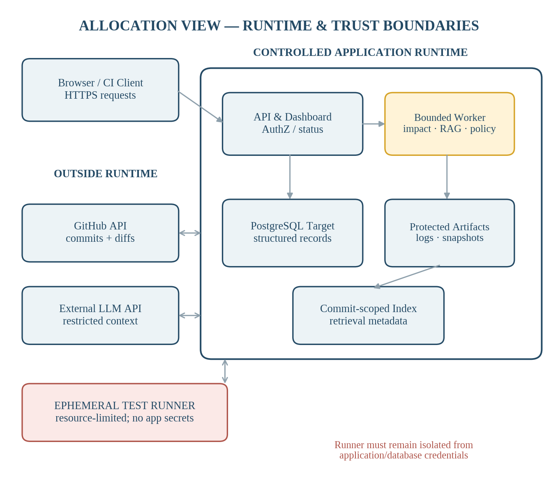
Figure 6.1. Proposed allocation and security boundaries

6.1 Node allocation and operational responsibilities
Node / store | Allocated components | Security and operational rule
Trial client | Web browser and CI/CD integration client | HTTPS; scoped access; no secret persistence in UI.
Application service | Web UI/API, access checks, run/status and reporting endpoints | Short-lived requests; never execute arbitrary repository tests inline.
Background worker | Git/AST analysis, indexing, retrieval, LLM interaction, validation and policy | Resource budgets, retries and stage persistence; secret references handled server-side.
Relational database | Versioned metadata and run-scoped structured records | PostgreSQL target, transactions, constraints and repository-level authorization.
Artifact storage and retrieval index | Snapshots/diffs/logs/reports; commit-indexed chunks and embeddings | Protected immutable storage; hash/namespace linkage; no reference-label leakage.
Isolated test runner | Target checkout, test discovery, selected/full execution | Ephemeral sandbox, allowed argv, CPU/memory/time caps, no API/DB credentials.
External providers | GitHub API and selected LLM API | Scoped authorization, minimal context, finite timeouts and budgets.

6.2 Deployment choices and non-goals
No Kubernetes cluster, dedicated distributed event broker or microservice mesh is needed for the MVP. A database-backed run queue or a small bounded worker scheduler is sufficient if it enforces single-claim semantics and recovery; the chosen mechanism must be verified through concurrent and replayed-request tests. A local or controlled CI/container environment is acceptable if repeatability, limits and result capture can be demonstrated.
The model provider and retrieval engine remain replaceable adapters. PostgreSQL is the database design target, but the selected persistence engine must be confirmed before migrations. The analyzed language and its test framework are independent of the backend implementation language and must be selected through an end-to-end checkout → diff → test discovery → single-test execution technical spike.

6.3 Architecture verification plan
Architectural concern | Verification evidence | Acceptance reference
Response and concurrency | Five-user API acknowledgement and status load test; simultaneous analysis requests. | NFR-02–03
Data/commit consistency | Attempt cross-repository and cross-run links; repeat a PR delivery with a new head. | NFR-05; FR-03–04
Selection invariants | Inject unknown IDs, missing evidence, valid empty inventories and LLM timeouts; inspect manifest. | FR-09–12; BR-03–06
Isolation and security | Run malicious test and prompt fixtures; verify no application secrets or command injection. | NFR-07–09
Failure and CI result | Simulate GitHub/runner failure and duplicate delivery; check terminal code and run count. | NFR-04; FR-17
Reproducibility and evaluation | Re-run frozen fixture; inspect artifacts, baseline metrics, missing-data handling and reference isolation. | NFR-11–12; FR-18

6.4 Design decisions requiring confirmation
Open item | Required confirmation / decision evidence
Analyzed language and test framework | Working AST/dependency and target inventory/discovery spike.
HTTP/frontend stack | Working status and report dashboard integrated with selected backend.
Database engine | Migration and transactional run-state verification against versioned schema.
Vector store and LLM model | Pinned model/version, retrieval namespace, test budget and redaction check.
Runner and CI/CD adapter | Sandbox execution controls and one idempotent pipeline integration.

